**Assignment 4**

**Name :** Gandhi Pritesh

All the devices are configured properly & routers are configured with **RIPv2**. All the networks are working in good condition. All the networks are able to connect & communicate with each other **properly**.

1)  Topology created in Microsoft Visio :

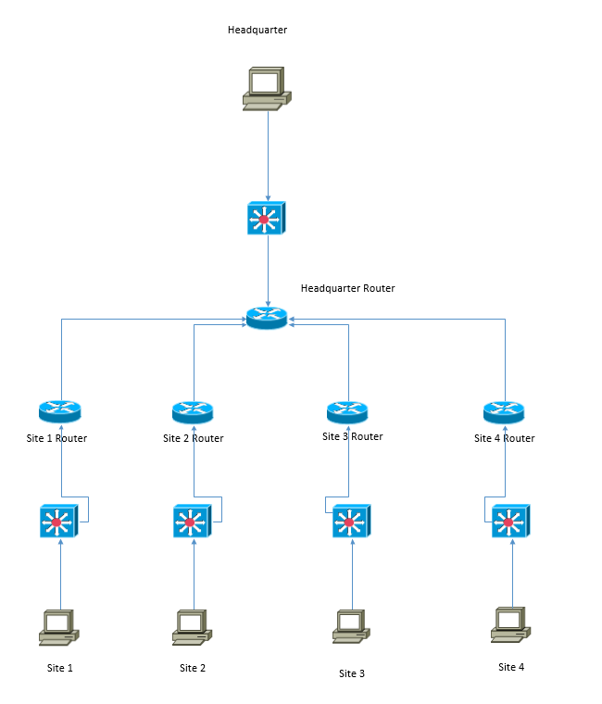

2)  Brief Description of what topic or technology you are concentrating on within this journal.

=>

* The main topic in this assignment is VLSM (Variable Length Subnet Mask).
* As we know while assigning IP address, lot of IP gets wasted because of unnecessary extra IP addresses given to a network as they are calculated on the basis of the maximum IP address required in the network. This wastage of IP address cannot be stopped , however, it can be reduced using VLSM.
* In VLSM, the IP address are divided into the subnets so that the requirement will be fulfilled & the wastage of IP addresses could be minimized.
* As per the given question, Company VARIABLE is a manufacturer of robotic birds used for U.S. military reconnaissance missions.  VARIABLE is a growing company and needs to utilize their IP Addresses in the most efficient way possible.  They are using the RFC1918 network address of 192.168.37.0/24.  VARIABLE has one headquarters site with 15 employees.  They also have four other remote sites each with 10 employees.
* Here if we follow the traditional method then the network address 192.168.37.0/24 will be divided into 8 subnets, each will have 32 IP addresses as the maximum required usable host addresses are 15 at headquarter. Other 4 sites need only 10 host addresses each. In this case, the remaining IP addresses will be waste.
* On the other hand, if we go with VLSM method, then we can obtain 1 subnet of 32 IP addresses for the headquarter & 4 subnets of 16 IP addresses for 4 sites. This will save 16 IP addresses at each site. So Total = 16 x 4 = 64 IP addresses will be saved which is huge saving.
* Calculation of subnets using VLSM is done as follow:

.0

.0 .128

.0 .64 .128 .192

.0 .32 .64 .96 .128

.0 - .31 Assigned to Headquarter LAN

.32 .48 .64 .80 .96 .112 .128

.96 .104

4 networks, each assigned to one of the four remote sites

.96 .100 .104 .108

Assigned to WAN connections

|  |  |  |  |  |  |
| --- | --- | --- | --- | --- | --- |
| **Subnets** | **Needed Hosts** | **Network Address** | **Mask** | **Assignable Range** | **Broadcast** |
| **Headquarter** | 15 | 192.168.37.0 | 255.255.255.224 | 192.168.37.1 - 192.168.37.30 | 192.168.37.31 |
| **Site 1** | 10 | 192.168.37.32 | 255.255.255.240 | 192.168.37.33 - 192.168.37.46 | 192.168.37.47 |
| **Site 2** | 10 | 192.168.37.48 | 255.255.255.240 | 192.168.37.49 - 192.168.37.62 | 192.168.37.63 |
| **Site 3** | 10 | 192.168.37.64 | 255.255.255.240 | 192.168.37.65 - 192.168.37.78 | 192.168.37.79 |
| **Site 4** | 10 | 192.168.37.80 | 255.255.255.240 | 192.168.37.81 - 192.168.37.94 | 192.168.37.95 |
| **WAN1** | 2 | 192.168.37.96 | 255.255.255.252 | 192.168.37.97 - 192.168.37.98 | 192.168.37.99 |
| **WAN2** | 2 | 192.168.37.100 | 255.255.255.252 | 192.168.37.101 - 192.168.37.102 | 192.168.37.103 |
| **WAN3** | 2 | 192.168.37.104 | 255.255.255.252 | 192.168.37.105 - 192.168.37.106 | 192.168.37.107 |
| **WAN4** | 2 | 192.168.37.108 | 255.255.255.252 | 192.168.37.109 - 192.168.37.110 | 192.168.37.111 |

**Results :**

1. Display the interfaces and verify each interface is in an UP/UP state

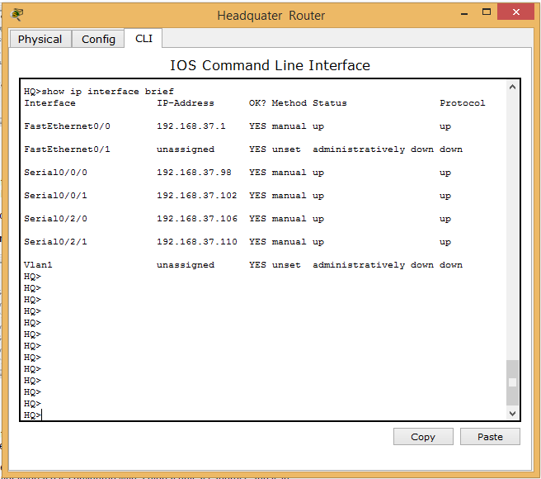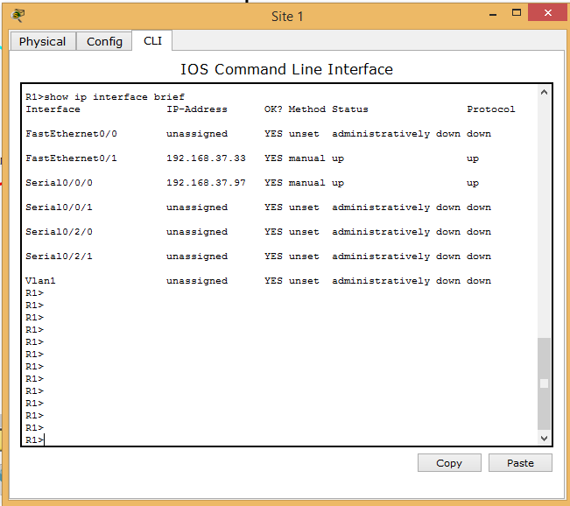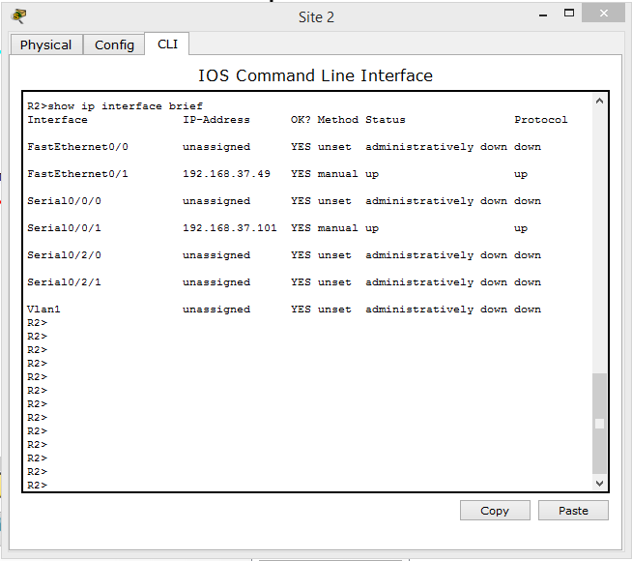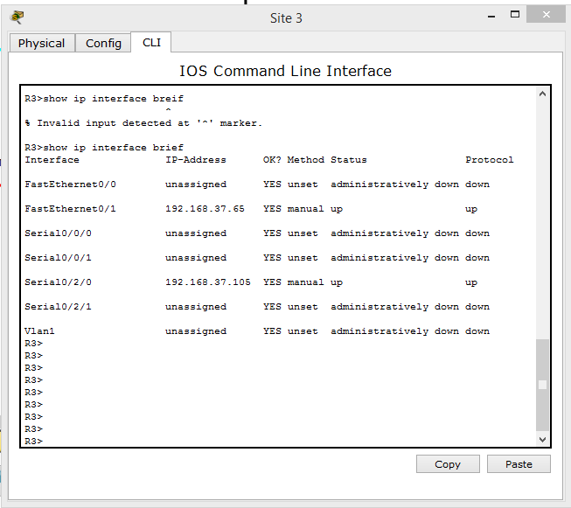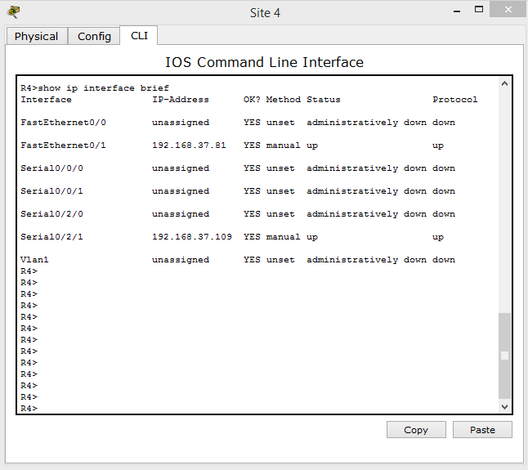

2)Display the routing tables within each of the routers

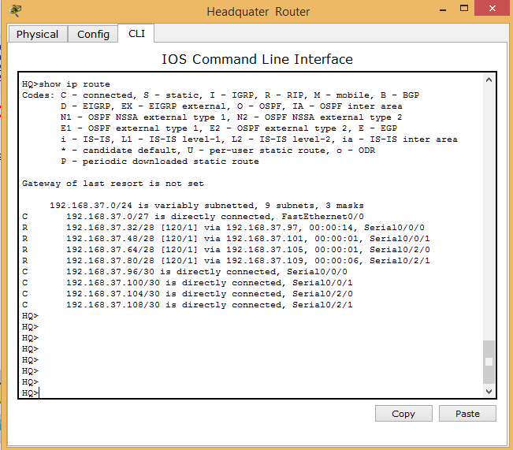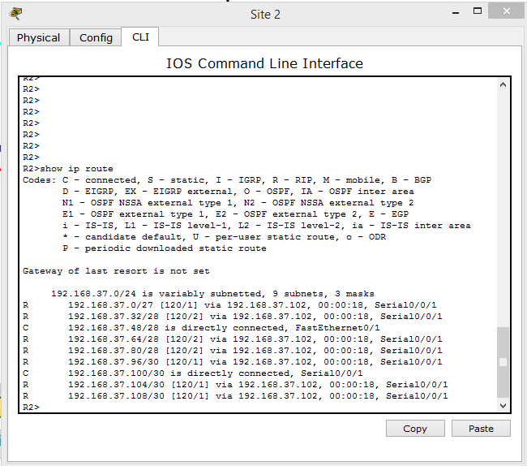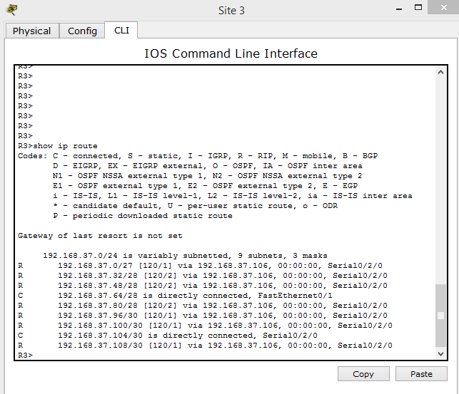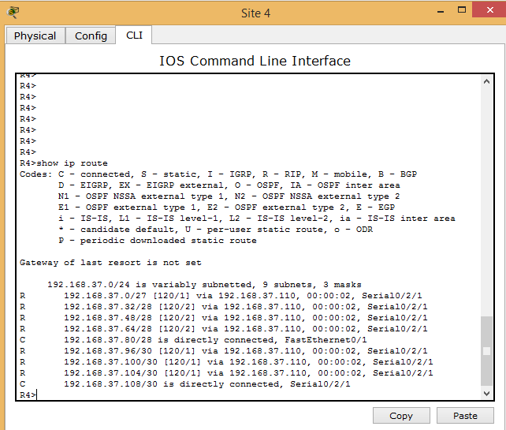

3)Display your interfaces in an abbreviated format so you see all of  the interfaces and their associated IP Addresses within one screen.











4)Display the routing protocol using "show ip protocols" for each router

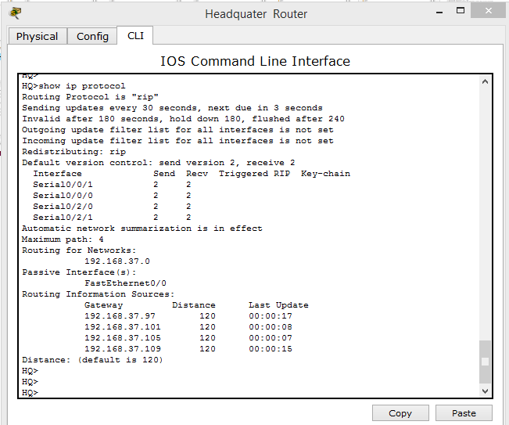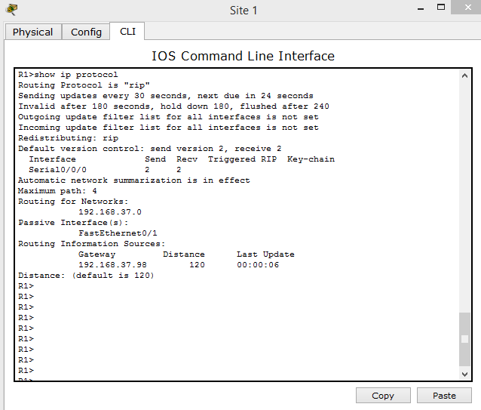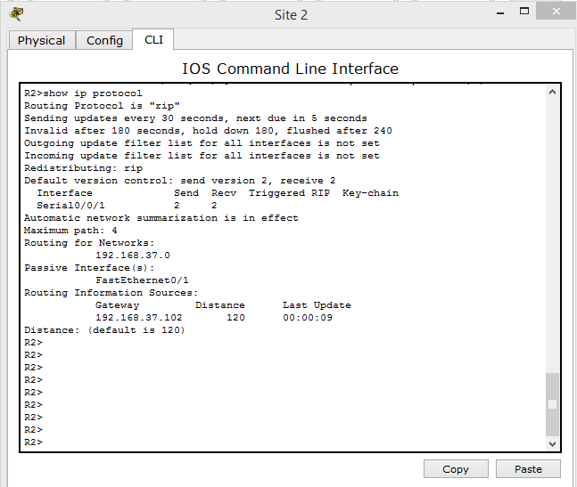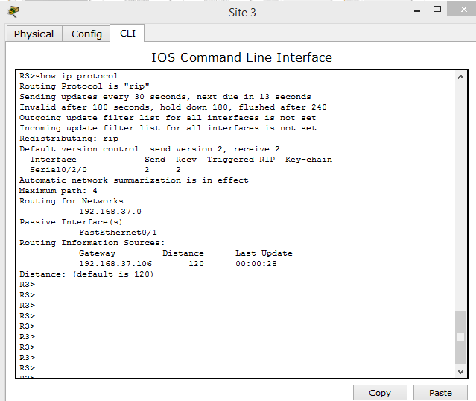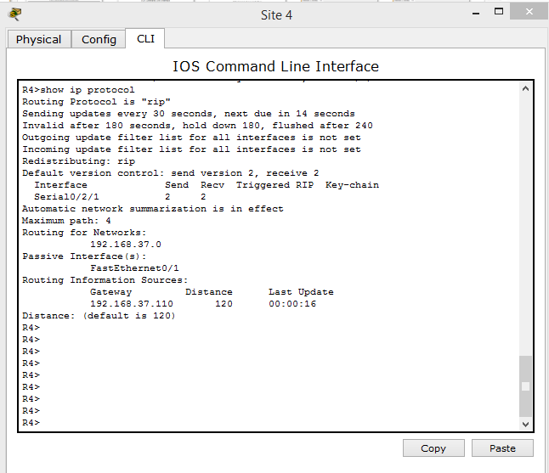

5) test connectivity –

**PC :**

Packet Tracer PC Command Line 1.0

PC>ping 192.168.37.5

Pinging 192.168.37.5 with 32 bytes of data:

Request timed out.

Reply from 192.168.37.5: bytes=32 time=1ms TTL=126

Reply from 192.168.37.5: bytes=32 time=1ms TTL=126

Reply from 192.168.37.5: bytes=32 time=1ms TTL=126

Ping statistics for 192.168.37.5:

Packets: Sent = 4, Received = 3, Lost = 1 (25% loss),

Approximate round trip times in milli-seconds:

Minimum = 1ms, Maximum = 1ms, Average = 1ms

PC>ping 192.168.37.36

Pinging 192.168.37.36 with 32 bytes of data:

Reply from 192.168.37.36: bytes=32 time=24ms TTL=128

Reply from 192.168.37.36: bytes=32 time=1ms TTL=128

Reply from 192.168.37.36: bytes=32 time=0ms TTL=128

Reply from 192.168.37.36: bytes=32 time=6ms TTL=128

Ping statistics for 192.168.37.36:

Packets: Sent = 4, Received = 4, Lost = 0 (0% loss),

Approximate round trip times in milli-seconds:

Minimum = 0ms, Maximum = 24ms, Average = 7ms

PC>ping 192.168.37.52

Pinging 192.168.37.52 with 32 bytes of data:

Request timed out.

Reply from 192.168.37.52: bytes=32 time=3ms TTL=125

Reply from 192.168.37.52: bytes=32 time=9ms TTL=125

Reply from 192.168.37.52: bytes=32 time=15ms TTL=125

Ping statistics for 192.168.37.52:

Packets: Sent = 4, Received = 3, Lost = 1 (25% loss),

Approximate round trip times in milli-seconds:

Minimum = 3ms, Maximum = 15ms, Average = 9ms

PC>ping 192.168.37.68

Pinging 192.168.37.68 with 32 bytes of data:

Request timed out.

Reply from 192.168.37.68: bytes=32 time=3ms TTL=125

Reply from 192.168.37.68: bytes=32 time=2ms TTL=125

Reply from 192.168.37.68: bytes=32 time=2ms TTL=125

Ping statistics for 192.168.37.68:

Packets: Sent = 4, Received = 3, Lost = 1 (25% loss),

Approximate round trip times in milli-seconds:

Minimum = 2ms, Maximum = 3ms, Average = 2ms

PC>ping 192.168.37.85

Pinging 192.168.37.85 with 32 bytes of data:

Request timed out.

Reply from 192.168.37.85: bytes=32 time=2ms TTL=125

Reply from 192.168.37.85: bytes=32 time=8ms TTL=125

Reply from 192.168.37.85: bytes=32 time=4ms TTL=125

Ping statistics for 192.168.37.85:

Packets: Sent = 4, Received = 3, Lost = 1 (25% loss),

Approximate round trip times in milli-seconds:

Minimum = 2ms, Maximum = 8ms, Average = 4ms

PC>tracert 192.168.37.97

Tracing route to 192.168.37.97 over a maximum of 30 hops:

1 11 ms 0 ms 0 ms 192.168.37.97

Trace complete.

PC>tracert 192.168.37.101

Tracing route to 192.168.37.101 over a maximum of 30 hops:

1 0 ms 0 ms 0 ms 192.168.37.33

2 0 ms 1 ms 1 ms 192.168.37.98

3 0 ms 3 ms 1 ms 192.168.37.101

Trace complete.

PC>tracert 192.168.37.105

Tracing route to 192.168.37.105 over a maximum of 30 hops:

1 1 ms 0 ms 0 ms 192.168.37.33

2 0 ms 1 ms 0 ms 192.168.37.98

3 1 ms 1 ms 0 ms 192.168.37.105

Trace complete.

PC>tracert 192.168.37.109

Tracing route to 192.168.37.109 over a maximum of 30 hops:

1 1 ms 0 ms 0 ms 192.168.37.33

2 2 ms 2 ms 0 ms 192.168.37.98

3 0 ms 0 ms 1 ms 192.168.37.109

Trace complete.

PC>

**Router Connectivity test :**

